Response to change

Template

Please complete this section of the template before doing the research.

Step 1:

Think of two change experiences you have recently experienced and on the template provided, provide an overview of what the change was.

1. A change imposed upon you – where you felt like you didn’t have a choice in the change. It can a be a small or large change; gradual or sudden; expected or unexpected.
2. An intentional change where it was a conscious decision by you to initiate or support a change.

|  |
| --- |
| Change that was imposed on me:  Last year I was working for a company and I had a great manager that I really respected. This manager was focused on providing me with development opportunities and I felt like I was really building my skills and getting exposed to lots of helpful career opportunities. We got along very well, were able to have a good laugh and I enjoyed coming into work. However, my manager got promoted and we received a new manager that I didn’t like. We didn’t connect at all. It was such a big change, as everything about the way we worked in the team felt different. The new manager’s style was very different as they were very task oriented and not so focused on my personal career development. It was all work and no play and no focus on building our skills for the long term. I felt really unhappy, frustrated and de-motivated. |
| Change that was intentionally generated by me:  I chose to change the course that I was studying at University, as I didn’t feel the first one was appropriate for me and it wouldn’t help me get to my end goal. I just wasn’t enjoying the course and it wasn’t what I expected it to be. It was a tough decision, but I decided to change courses as soon as I could rather than waste time on pursuing the other qualification. |

Step 2:

Think about and record the range of reactions you experienced (mindset/emotions and behavior) as you went through the changes – from the beginning to the end.

|  |
| --- |
| The range of reactions experienced for the change that was imposed on me was:  When I was first told that I was getting a new manager, I felt anxious as I didn’t know the person and I was really upset about losing my old manager. I liked and respected my old manager. This new manager had big shoes to fill! My expectations were very high, and I wasn’t happy about the change. When the new manager started, I felt that they didn’t like me and were nothing like my old manager. It was hard and I felt demotivated as they managed me in a totally different way and didn’t seem to trust me at all. I tried to show them how capable I was, but they just gave me endless tasks to do and never praised me for the tasks I was doing well. After feeling frustrated and angry, I asked for a meeting with my manager and told them how I felt. This was a very scary thing to do and it took a lot of courage. I was nervous. They were shocked by what I said as my manager had no idea about how I was feeling and what I needed to help me be successful and happy at work. We agreed to work out a plan for the way forward and how to make it work for us both. I felt hopeful after that meeting and proud of myself for having a constructive conversation about this. We slowly began to improve our relationship and now we have a very positive working relationship and I am back to feeling motivated at work. |
| The range of reactions experienced for the changed that I intentionally generated was:  I was nervous making such a big decision to change my course and I even felt like I was letting people down and had failed. But, as soon as I made the decision and the process to change courses started to happen, it was like a weight lifted from me and I was so happy to start my new course – I was excited about the future. I did have a few moments where I was worried, I’d made the wrong choice, but it turned out to be the correct choice and now I’m coming to the end of my course and I know I made the right decision. |

Step 3:

Complete the reading and research in the additional resources to get a better understanding of ‘why’ you experienced what you did and then complete the next page.

Step 4:

Now that you’ve done your research about the Change Curve, please complete the final section. Here is a reminder of the Change Curve:

The Kübler-Ross change curve

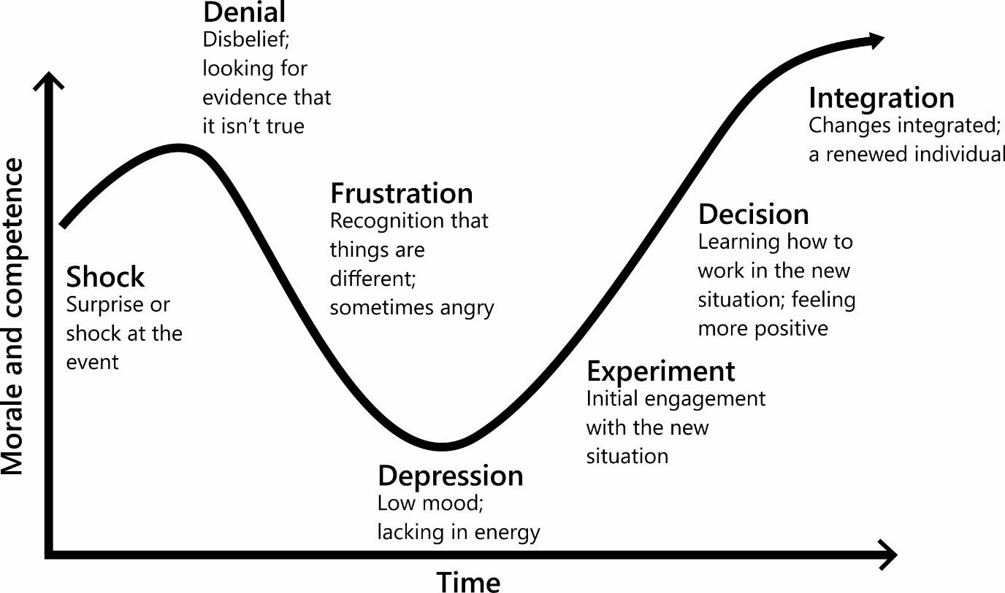

Step 5:

Identify what you have learnt from reflecting on this experience. Thinking back to the changes you wrote about earlier, identify what you have learnt from reflecting on this experience. It would also be beneficial to detail what happened at each stage of the Change Curve for you.

|  |
| --- |
| My reflections and learnings for the change that was imposed on me:  I learnt that I need to speak up when things aren’t going right for me, to ensure there is an  opportunity to put it right.  Shock: I now understand that I was in shock when I was first told that my manager was not going to manage me anymore. I really didn’t expect it.  Denial: I definitely had a moment of denial, as I was so upset about losing my manager that I just  didn’t want to accept that it was happening.  Frustration: I got very frustrated and I think I stayed at this stage for quite a while, as I just couldn’t see a way forward from this. It also made me angry with how I was being managed and I found this difficult to cope with – everything had changed, and I really didn’t like it. I felt like my career development was being negatively impacted by someone else.  Depression: I definitely recognize that my motivation dropped, and I didn’t have the same energy  as I used to. In reflection, this may have been part of the problem, as perhaps this meant that I  wasn’t performing as well as I used to, so the new manager didn’t know my capabilities. I also think I possibly didn’t make it easy for this new manager as I was continuously comparing them to my old manager. I didn’t really give them a proper chance to begin with or see how this change was also difficult for them. I didn’t start the relationship with an open mind as I just wanted them to replace my old manager and keep everything the same.  Experiment: I asked for a meeting with my new manager to talk about how they were making me feel. I think this was me trying to engage with them and find a better way of working. I was close to leaving the company but decided to try this approach first. It really was a bit of an experiment, but it paid off.  Decision: I think after the meeting we had a clearer understanding of how each of us liked to work, we could both move forward and progress with a new way of working. I think they respected me for wanting to try and improve the relationship.  Integration: The change is now integrated and working reasonably well. I didn’t leave the company (which was good because I didn’t really want too) and I ended up with a good relationship with my new manager – it was just different to my relationship with my previous manager. |
| My reflections and learnings for that change that I intentionally generated:  I learnt that I need to trust my own judgment and believe in myself.  *Shock:* I was aware that I was on the wrong course and felt a bit surprised by the fact that I’d made such a wrong decision for myself in the first place. I wasn’t sure at first if I could change course or what I could possibly do about it.  *Denial:* I remember thinking that I should stay on the current course, as I’d already put in so much hard work and I didn’t think my family would be happy. I felt like I would be a failure if I didn’t stay the course.  *Frustration:* I continued to feel frustrated with myself for making the wrong decision initially, as I felt I had wasted time on the first course and I really wasn’t happy or motivated anymore. I started procrastinating a lot!  *Depression:* I did lose focus for a little while and didn’t put much effort into my studies for some time. I don’t think I was such a nice person to be around at this stage as I was grumpy, tired and irrational at times.  *Experiment:* I decided to seek advice from the careers counsellor at University and find out what my options were. As soon as I knew what the options were and I could do something about it, I made a decision fairly quickly.  *Decision:* Once I made the decision to change courses and put that plan into place, I felt energized and started doing extra reading to prepare me for the change in topic and catch-up anything I had missed. I was really excited and so motivated again. Everyone around me noticed how my mood had lifted and I was back to being my old self again.  *Integration:* Now I have changed my course; I feel really happy. I have learned I should really listen  to how I am feeling and seek out information or support to see how I can make changes that result in me feeling energized, motivated, positive and future focused. |

Any final thoughts or reflections on how you could deal with change more effectively in the future?

 10 tips for coping with big changes in your life and coming out a better person for it.

**1. Acknowledge that things are changing.**

Sometimes we get so caught up in fighting change that we put off actually dealing with it. Denial is a powerful force, and it protects us in many ways. However, stepping outside of it and saying to yourself, "Things are changing, and it is okay" can be less [stressful](https://www.psychologytoday.com/us/basics/stress) than putting it off.

**2. Realize that even good change can cause stress.**

Sometimes when people go through a positive life change, such as graduating or having a baby, they still feel a great deal of stress—or even dread. Keep in mind that positive change can create stress just like not-so-positive change. Stress is just your body's way of reacting to change. It's okay to feel stressed even when something good has happened—in fact, it's normal.

**3. Keep up your regular schedule as much as possible.**

The more change that is happening, the more important it is to stick to your regular schedule—as much as possible. Having some things that stay the same, like walking the dog every morning at 8 am, gives us an anchor. An anchor is a reminder that some things are still the same, and it gives your brain a little bit of a rest. Sometimes when you are going through a lot of change it helps to write down your routine and check it off as you go. It's one less thing for your brain to have to hold inside.

**4. Try to eat as healthily as possible.**

When change happens, a lot of us tend to reach for carbs—bread, muffins, cake, etc. This may be because eating carbs boosts serotonin—a brain chemical that may be somewhat depleted when you undergo change (stress). It's okay to soothe yourself with comfort foods—in moderation. One way to track what you are eating is to write it down. You can either do this in a notebook or use an app. When you see what you are eating, it makes you take a step back and think about whether you want to eat that second muffin or not. (If you have a history of [eating disorders](https://www.psychologytoday.com/us/conditions/eating-disorders), it is not recommended that you write down what you are eating.) Also notice if you are experiencing an increased use of [alcohol](https://www.psychologytoday.com/us/basics/alcohol) or other substances; your use can sneak up on you when you are under stress.

**5. Exercise.**

Keeping up regular exercise could be a part of the "keep up your regular schedule" tip. If exercise is not currently part of your routine, try adding it. Exercising two to three times a week has been found to significantly decrease symptoms of [depression](https://www.psychologytoday.com/us/basics/depression) (Barclay, et al. 2014.) Even just walking around the block can help you feel better. (Check with your doctor before starting an exercise program.) Remember, you don't have to feel like getting some exercise; just get out there and move. You'll find that many times your [motivation](https://www.psychologytoday.com/us/basics/motivation) will kick in while you are active.